Robotic arm wiring instructions

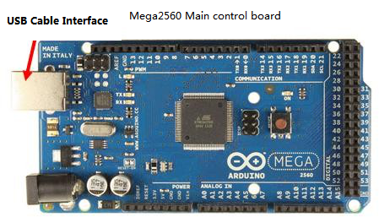

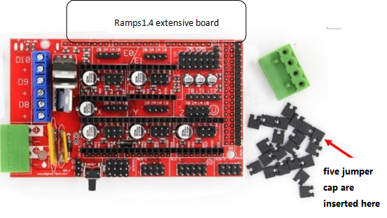
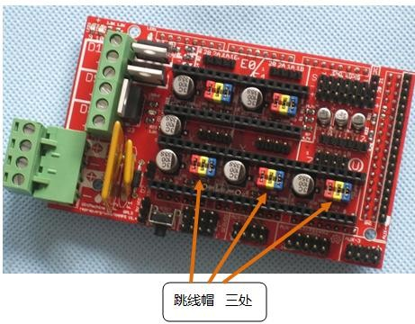

Jumper cap installation

Three jumper caps

Plugging the jumper cap is for setting drive subdivision

See the table below for details. ( yes for plugging in)

ms1 | ms2 | ms3 | (pin character)
no | no | no | Full subdivision
yes | no | no | 1/2 subdivision
no | yes | no | 1/4subdivision
yes | yes | no | 1/8subdivision
yes | yes | yes | 1/16subdivision

Driver board installation
A4988 drive board

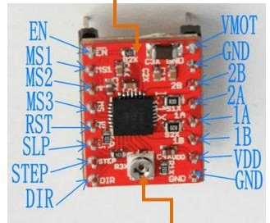

Potentiometer knob can change the current

The current of 4988 chip is preferably below 1.2A without a heat sink , ; With a heat sink, it can reach 2A.

the torque of the stepper motor is is directly related to the magnitude of the drive current. If the stepper motor has insufficient torque , increase the current configuration of the 4988 board.
The output current is configured by a small potentiometer by drive board. The potential of the potentiometer intermediate pin can be measured by using a multimeter.

The potential and current satisfies the following formula: Vref = I_TripMax*0.8 (The module's Rs resistance is R100). for example, when the Motor operating current is 1A, the potential should be at 0.8V. The default current is 1.5A . If more current is needed, modify R1 in the circuit.

Ramp1.4 Installation
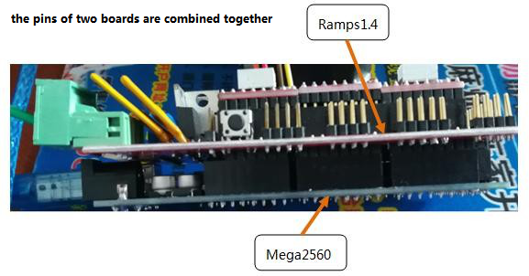

Motor wiring and power wiring

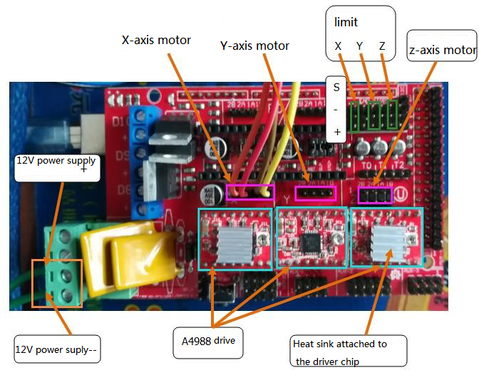

The motor used here is a two-phase four-wire stepper motor in which black and green are one phase and red and blue are one phase. If the color of the lead wire of the motor is different from that in this document, connect the wire of the same phase to the non-inverting pin. Exchange the two wires in the same phase if the motor is found to be in the wrong direction when debugging the motor.
The color of the motor lead-out line is as follows: black is connected to A1, green is connected to B1, red is connected to A2, and blue is connected to B2. A1 and B1 are one phase, and A2 and B2 are one phase.
Just power Ramps1.4 (12v), pay attention to the positive and negative poles.

Do not insert the A4988 driver module reverse or misalignment, otherwise the motherboard chip will be burned out. Please check the direction of the A4988 driver module before plugging in.

The corresponding XYZ axis motor is shown below

